**ER Diagram - PART 1**

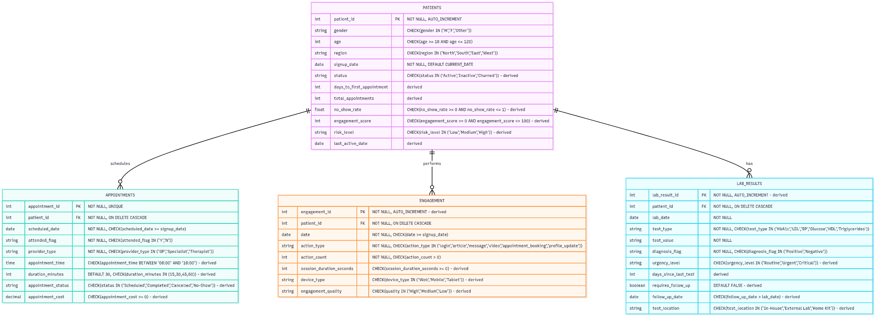

Data Model Documentation :

PRIMARY KEYS AND FOREIGN KEYS

Primary Keys (PK):

- PATIENTS: patient_id (AUTO_INCREMENT, NOT NULL)

- APPOINTMENTS: appointment_id (UNIQUE, NOT NULL)

- ENGAGEMENT: engagement_id (AUTO_INCREMENT, derived composite key)

- LAB_RESULTS: lab_result_id (AUTO_INCREMENT, derived composite key)

Foreign Keys (FK):

- APPOINTMENTS: patient_id → PATIENTS.patient_id (ON DELETE CASCADE)

- ENGAGEMENT: patient_id → PATIENTS.patient_id (ON DELETE CASCADE)

- LAB_RESULTS: patient_id → PATIENTS.patient_id (ON DELETE CASCADE)

RELATIONSHIPS & CARDINALITY

- PATIENTS to APPOINTMENTS: One-to-Many (1:N) - Mandatory participation on APPOINTMENTS side

- PATIENTS to ENGAGEMENT: One-to-Many (1:N) - Optional participation

- PATIENTS to LAB_RESULTS: One-to-Many (1:N) - Optional participation

DATABASE CONSTRAINTS

PATIENTS Table Constraints:

- patient_id: PRIMARY KEY, AUTO_INCREMENT, NOT NULL

- gender: CHECK constraint - Must be 'M', 'F', or 'Other'

- age: CHECK constraint - Must be between 18 and 120 (legal adults only)

- region: CHECK constraint - Limited to 'North', 'South', 'East', 'West'

- signup_date: NOT NULL, DEFAULT CURRENT_DATE

- status: CHECK constraint - 'Active', 'Inactive', or 'Churned' (derived)

- no_show_rate: CHECK constraint - Must be between 0 and 1 (percentage as decimal)

- engagement_score: CHECK constraint - Must be between 0 and 100

- risk_level: CHECK constraint - 'Low', 'Medium', or 'High' (derived from engagement patterns)

APPOINTMENTS Table Constraints:

- appointment_id: PRIMARY KEY, UNIQUE, NOT NULL

- patient_id: FOREIGN KEY, NOT NULL, CASCADE DELETE

- scheduled_date: NOT NULL, Must be >= patient's signup_date

- attended_flag: NOT NULL, CHECK constraint - Only 'Y' or 'N'

- provider_type: NOT NULL, CHECK constraint - 'GP', 'Specialist', or 'Therapist'

- appointment_time: CHECK constraint - Between 08:00 and 18:00 (business hours)

- duration_minutes: DEFAULT 30, CHECK constraint - Must be 15, 30, 45, or 60

- appointment_cost: CHECK constraint - Must be >= 0

ENGAGEMENT Table Constraints:

- engagement_id: PRIMARY KEY, AUTO_INCREMENT

- patient_id: FOREIGN KEY, NOT NULL, CASCADE DELETE

- date: NOT NULL, Must be >= patient's signup_date

- action_type: NOT NULL, CHECK constraint - Limited to defined action types

- action_count: NOT NULL, Must be > 0

- session_duration_seconds: CHECK constraint - Must be >= 0

- device_type: CHECK constraint - 'Web', 'Mobile', or 'Tablet'

- engagement_quality: CHECK constraint - 'High', 'Medium', or 'Low'

LAB_RESULTS Table Constraints:

- lab_result_id: PRIMARY KEY, AUTO_INCREMENT

- patient_id: FOREIGN KEY, NOT NULL, CASCADE DELETE

- lab_date: NOT NULL

- test_type: NOT NULL, CHECK constraint - Limited to defined test types

- test_value: NOT NULL

- diagnosis_flag: NOT NULL, CHECK constraint - 'Positive' or 'Negative'

- urgency_level: CHECK constraint - 'Routine', 'Urgent', or 'Critical'

- requires_follow_up: DEFAULT FALSE

- follow_up_date: Must be > lab_date when populated

- test_location: CHECK constraint - 'In-House', 'External Lab', or 'Home Kit'

**DERIVED ATTRIBUTES**

PATIENTS Table:

- status: Status is calculated from the last activity date (Active: >30 days; Inactive: 30-90 days; Churned: > 90 days)

- days_to_first_appointment: DATEDIFF(fsignup_date, first appointment_date)

- total_appointments: total_appointments COUNT(appointments) each patient

- no_show_rate: COUNT(attended_flag='N') / COUNT(appointments)

- engagement_score: Engagement is not calculated as a total score but is distributed weights on the frequency, recency, and variety of actions

- risk_level: Determined as a factor of no_show_rate and engagement_score

- last_active_date: last_active_date MAX(engagement.date, appointments.scheduled date)

APPOINTMENTS Table:

- appointment_time: Calculated from scheduled_date and/or business logic

- duration_minutes: Provider_type based (GP=30, Specialist=45, Therapist=60)

- appointment_status: Determined from attended_flag and scheduled_date

- appointment_cost: Provider type and duration based

ENGAGEMENT Table:

- engagement_id: AUTO_INCREMENT for uniqueness

- session_duration_seconds: Computed from session timestamps

- device_type: Extracted from user agent or session metadata

- engagement_quality: Derived from action_count and session_duration

LAB RESULTS Table:

- lab_result_id: AUTO_INCREMENT for uniqueness

- urgency_level: Assigned from value ranges and diagnosis_flag

- days_since_last_test: Computed from previous test of same type

- requires_follow_up: Diagnostic_flag='positive' or abnormal values

- follow_up_date: Determined by the ranking

- test_location: Scheduling system or test_type based